|  |
| --- |
| ***Date: / / 18***  **[cloud computing]** |
|  |

Practical: 7

**AIM: Eucalyptus configuration**

Submitted By: Samip Shah

Enrollment No: 15012011045



**GANPAT UNIVERSITY**

**U. V. Patel College of Engineering**

**Computer Engineering Department**

* **Supported Linux platforms**
* Ubuntu, RHEL, Centos, and Debian
* We use UEC (Ubuntu Enterprise Cloud) available with Ubuntu 10.04.4 server OS
* Other option is
  + Manually install all the components
  + Recommended for experts
* **A typical cloud Setup**
* 1 Cloud controller server, each server has
  + Cloud controller
  + Walrus
* Many Cluster controllers, each server has
  + Cluster controller
  + Storage controller
* Many node controllers under each Cluster Controller
  + Each node controller is one physical machine
* **We use minimal setup(Network Configuration)**

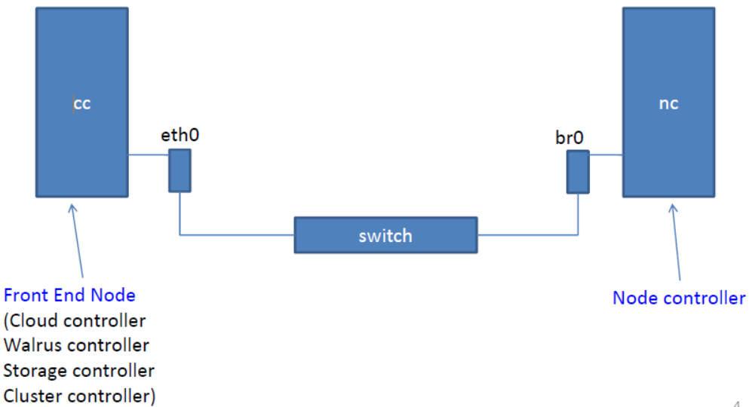

* **Cloud Setup**
* Eucalyptus network
  + We will be using the default network configuration of “Managed-
  + NoVLAN”
* “Managed-NoVLAN”
  + provides dynamic IP assignment for VMs and
  + allows us to control ingress traffic by building iptables profiles known as security groups.
  + Another mode of network configuration known as “Managed” mode

provides the additional feature of VM network isolation.

* Main configuration file
  + Eucalyptus configuration is stored in /etc/eucalyptus/eucalyptus.conf
  + Configuration can be changed after installation. You need to restart

service using following command:/etc/init.d/(service-name) restart

* **Setup inside Type-2 hypervisor (e.g.,Oracle VirtualBox or VMware Player)**
* Server 1 (Cloud controller or frontend)
  + 15 GB Hard disk
  + Min. 512MB RAM
  + Host only network adapter
  + Intel VT is not required
* Server 2 (Node controller)
  + 20 GB Hard disk
  + Min 1.5GB RAM
  + Host only network adapter
  + Intel VT is required
* **Installation**
* **Setup server-1**
* First we setup server-1, i.e. Cloud Controller.

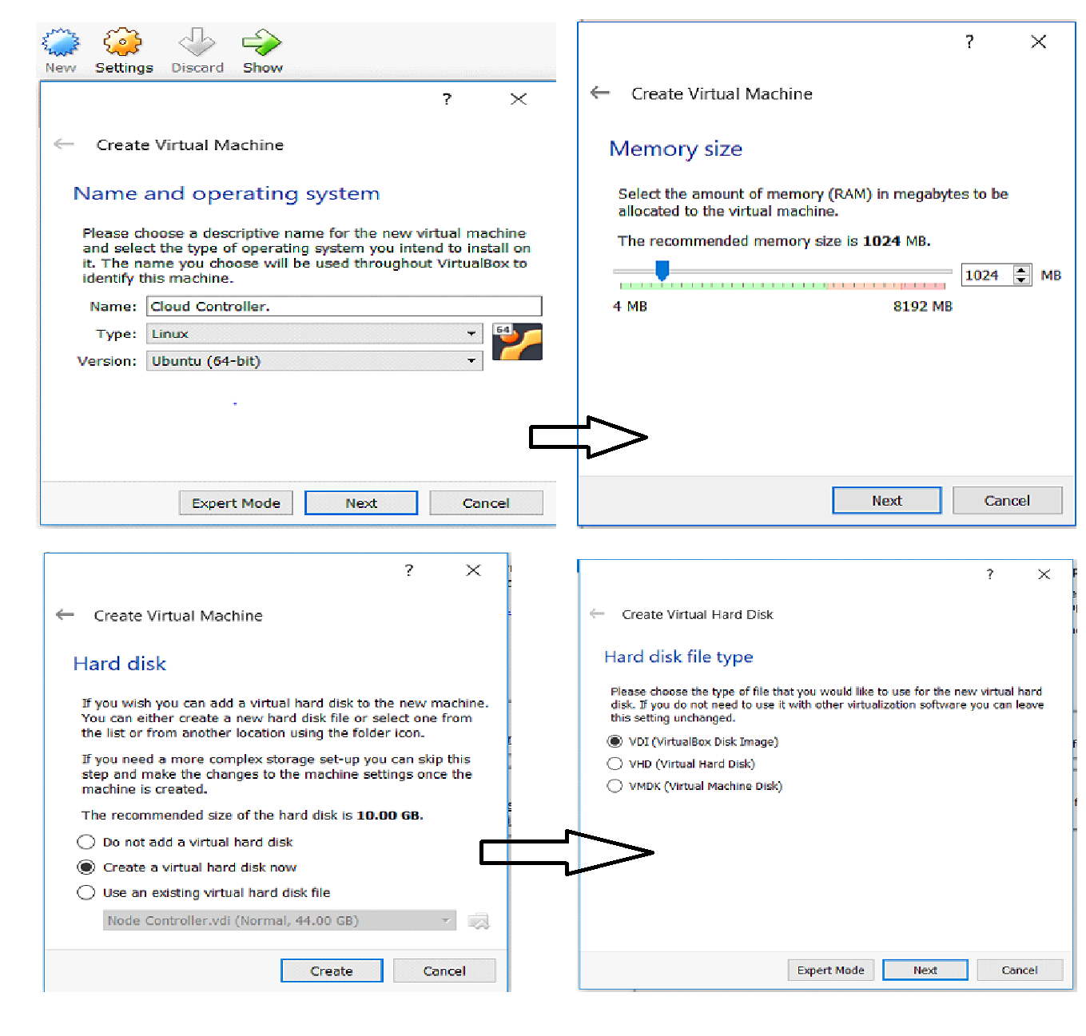

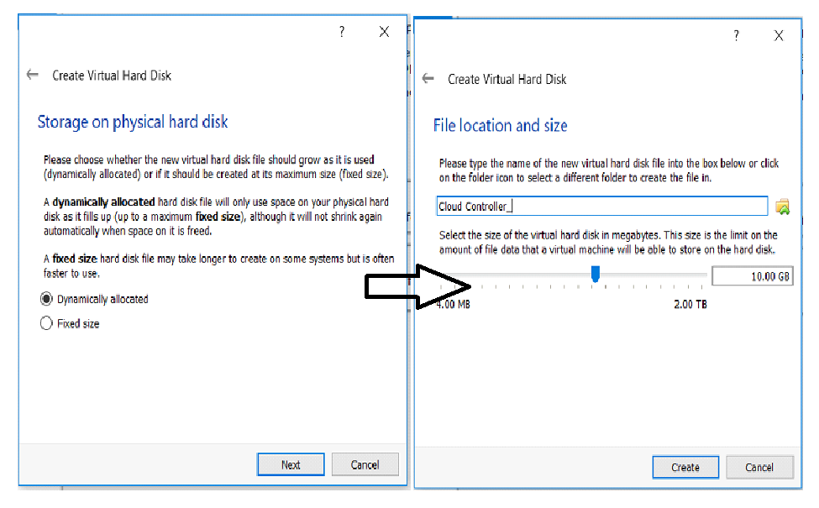

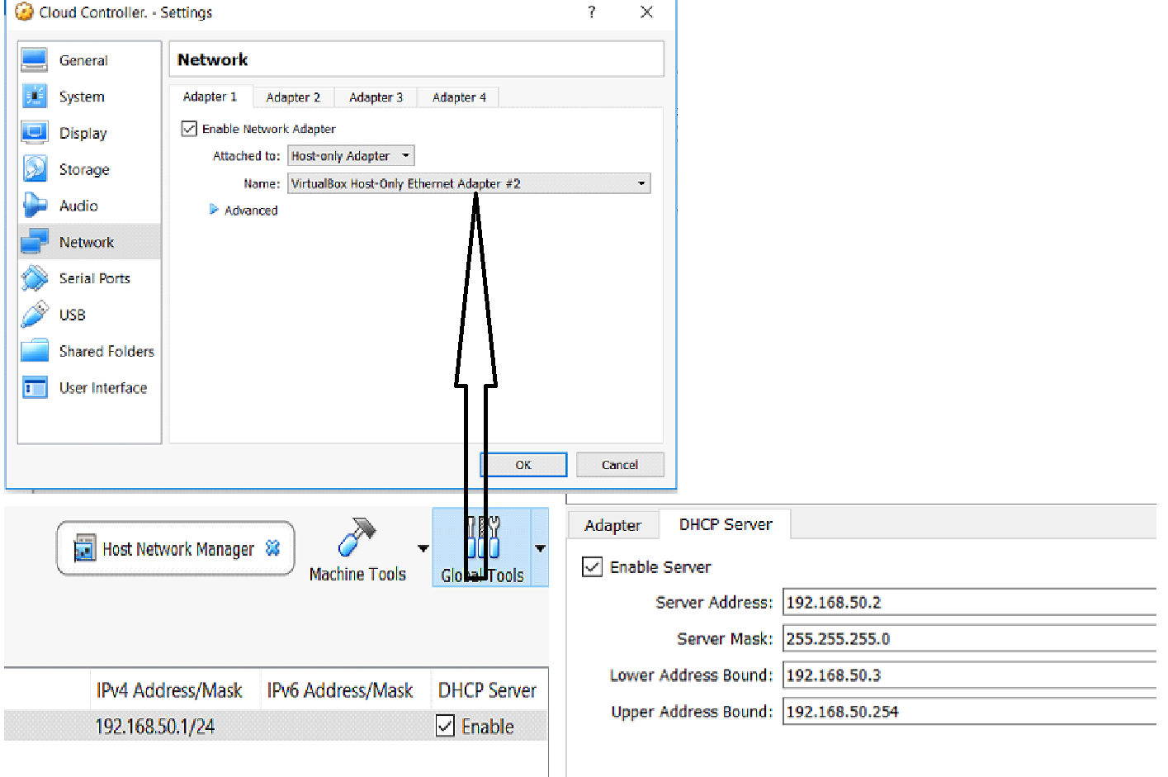

* We build our cloud controller (cc) by Using Virtual box Start Up Desk & “Install Ubuntu Enterprise Cloud” from the menu

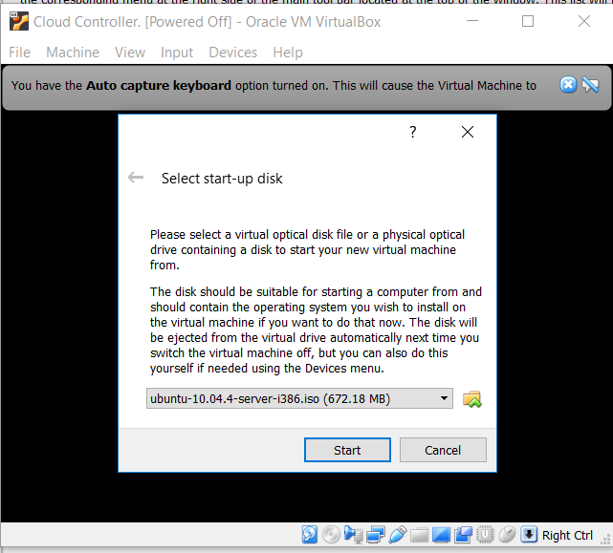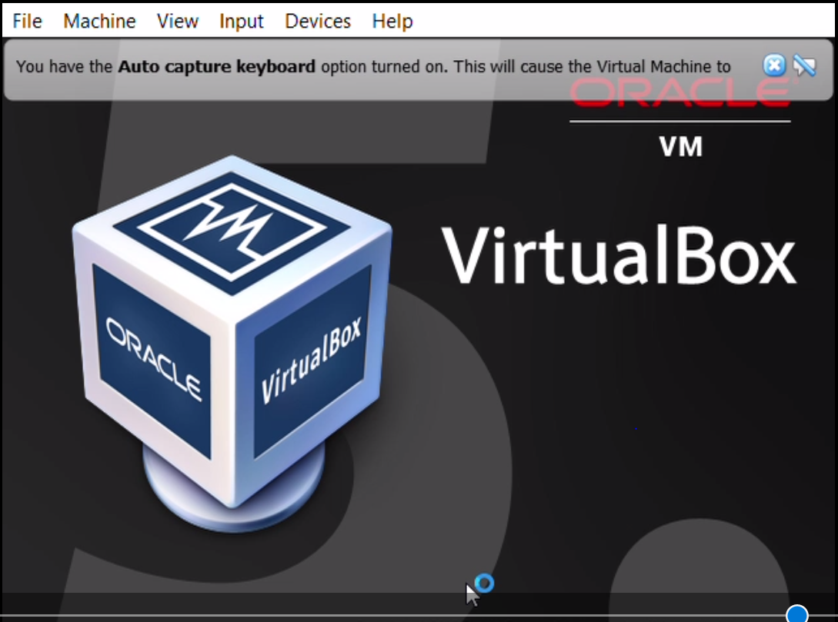

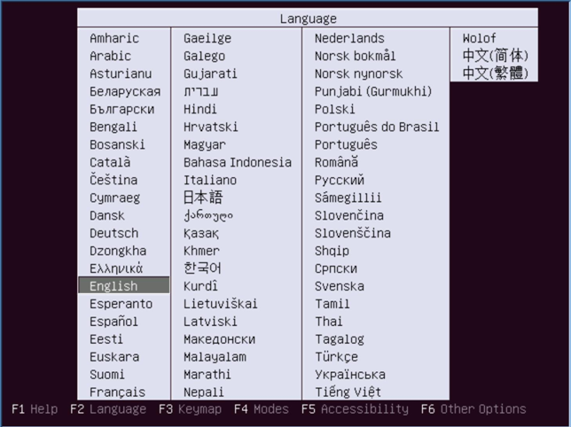

* Select “Install Ubuntu Enterprise Cloud”

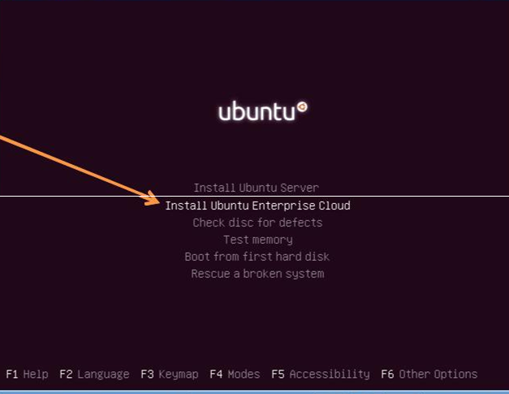

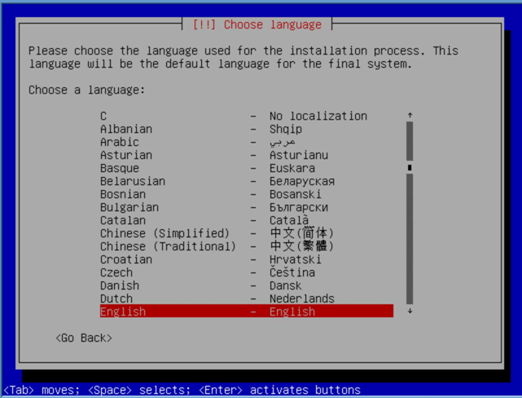 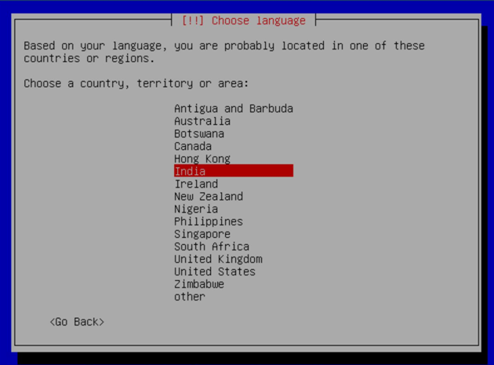

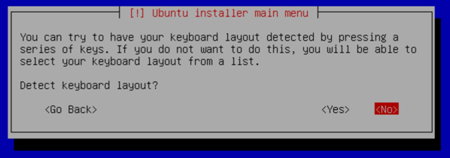

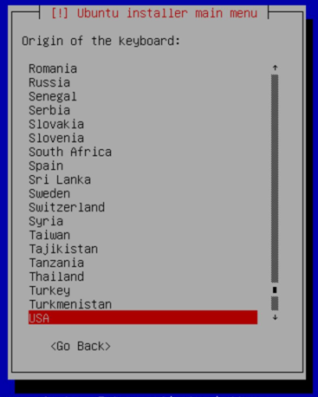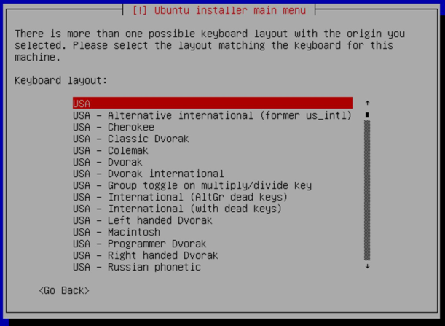

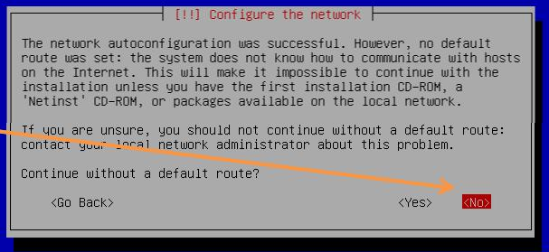

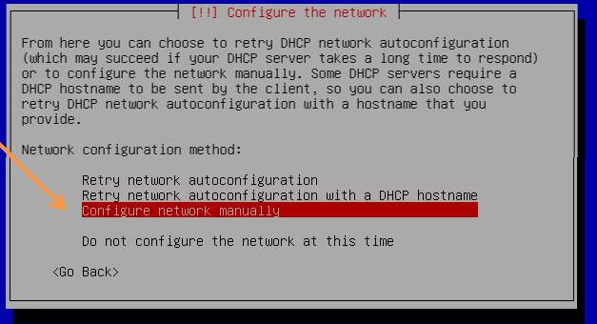

* **Give IP Adders Which is Available AT “Host Network Manager”**

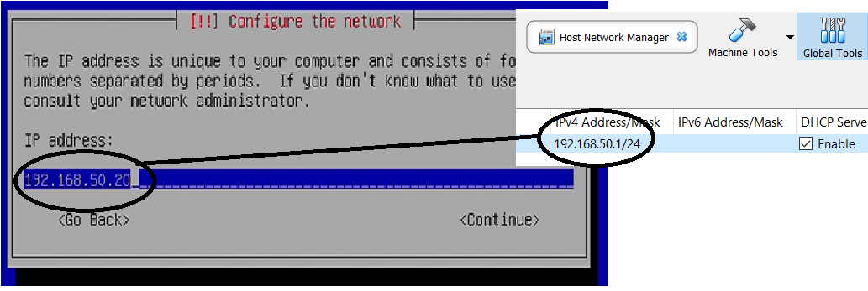

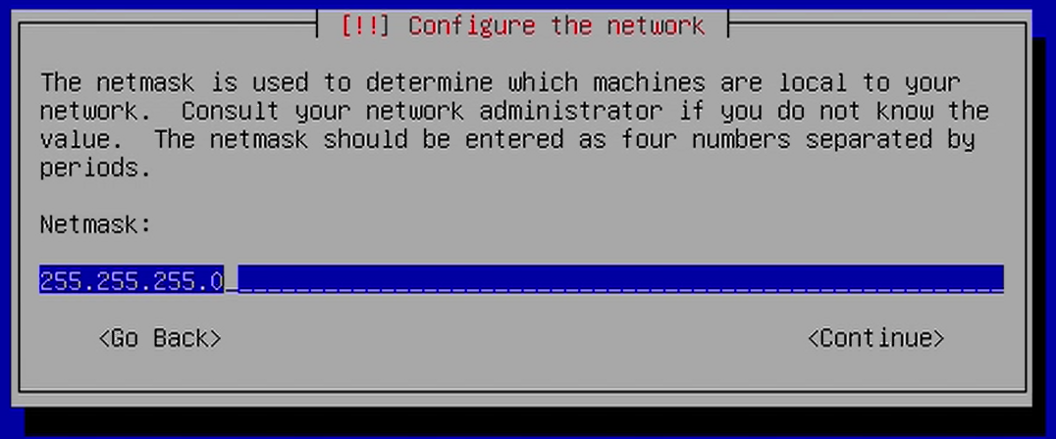

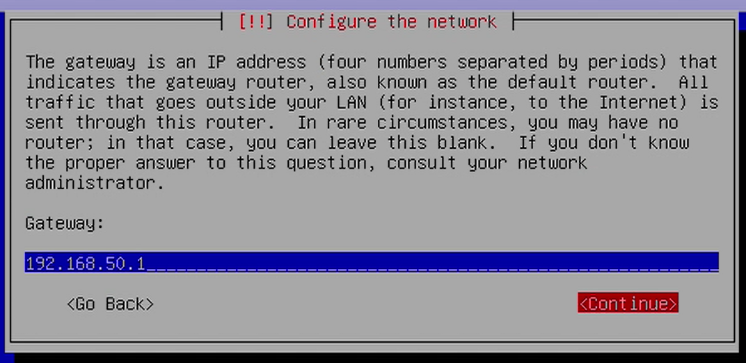

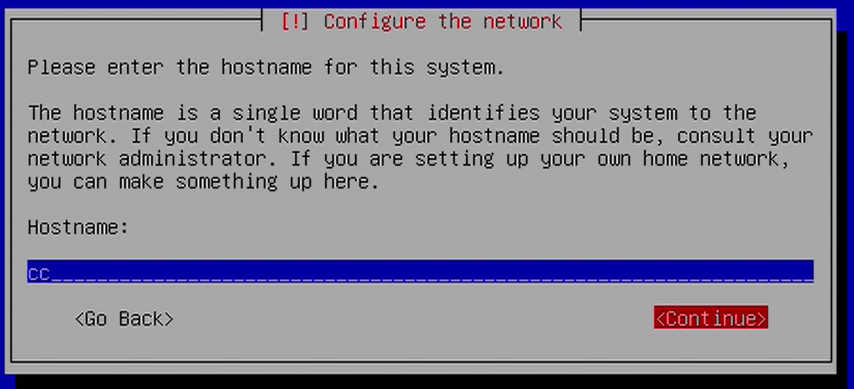

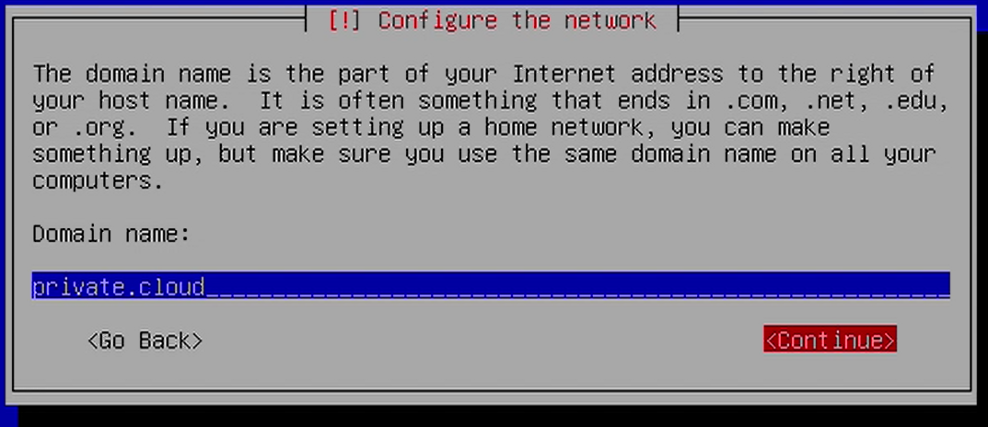

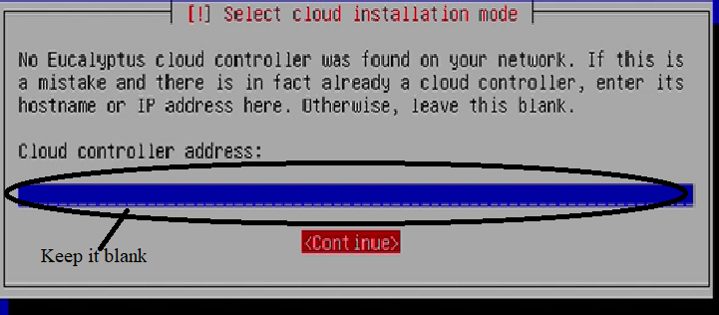

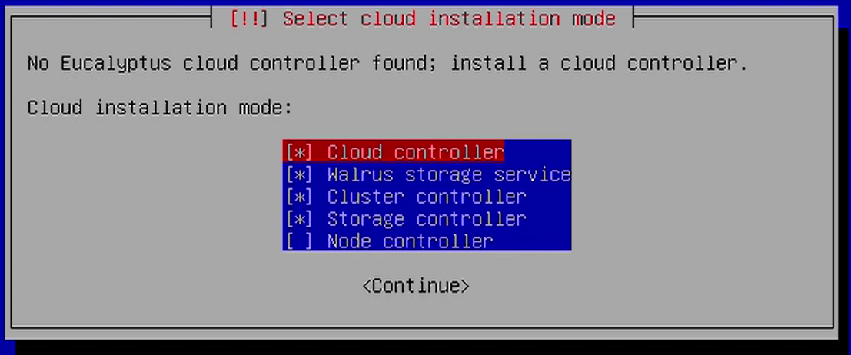

* **Selection of Components**
* In larger and/or more complex installations, each of the unctions shown in menu (next screen) may be divided onto separate physical
* servers.
  + Eucalyptus private cloud has a single cloud controller,
  + But there can be multiple cluster controllers within the cloud,
  + and multiple node controllers reporting to each cluster controller.
  + Walrus is the data storage component of Eucalyptus, which is
* similar to Amazon’s Simple Storage Service (S3).
  + We choose the role first server will play in our cloud.
  + For our demonstration, we use a single-cluster installation and
* accept the default cloud installation mode of Cloud controller,
* Walrus storage service, cluster controller, and storage controller.

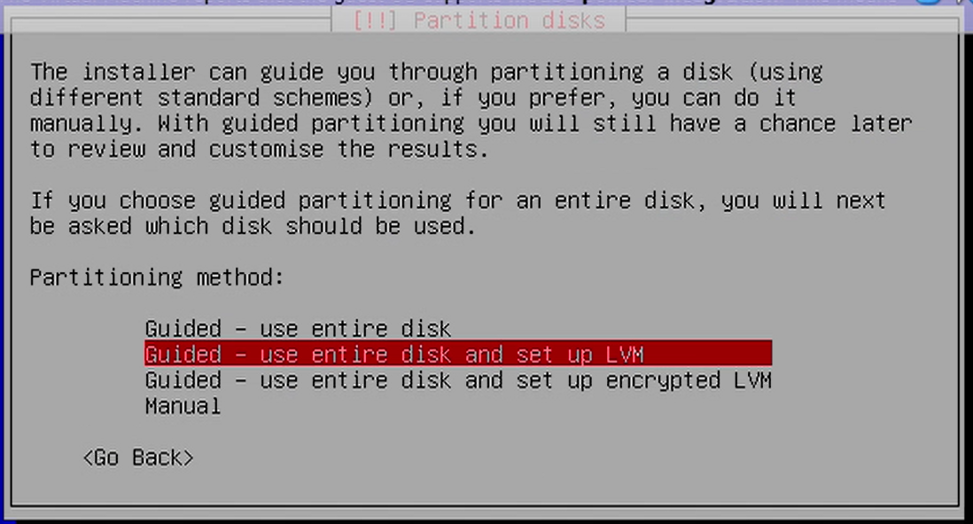

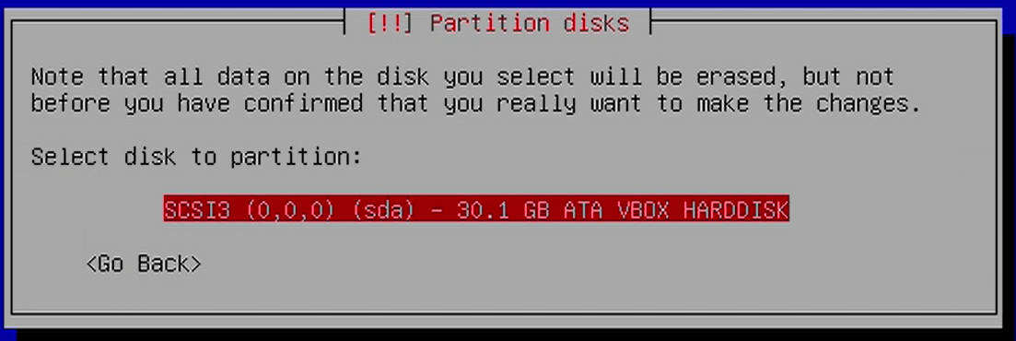

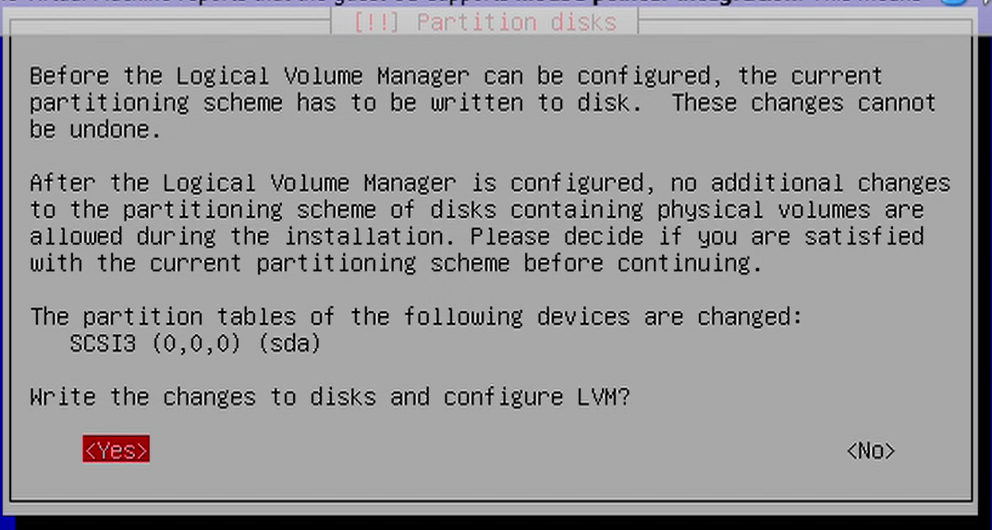

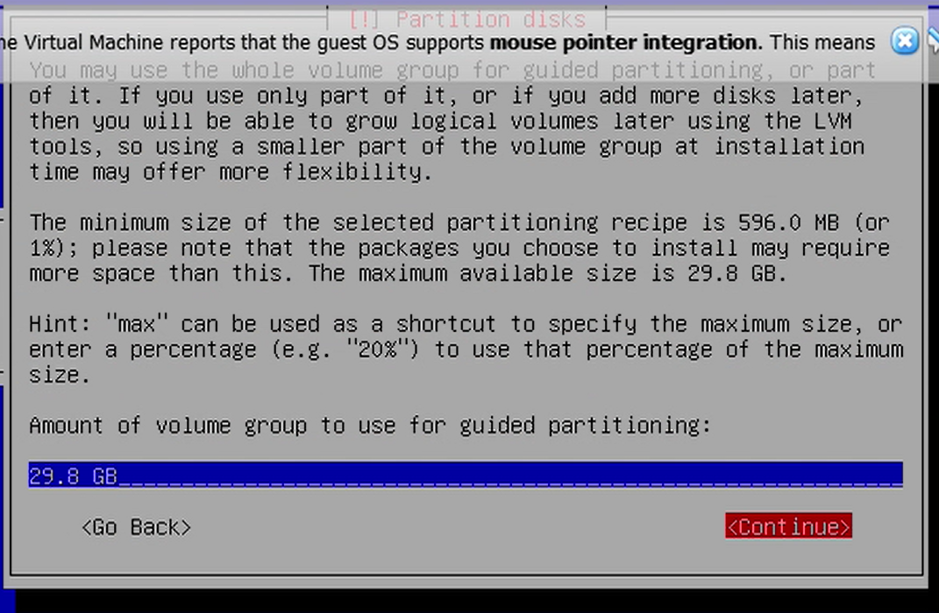

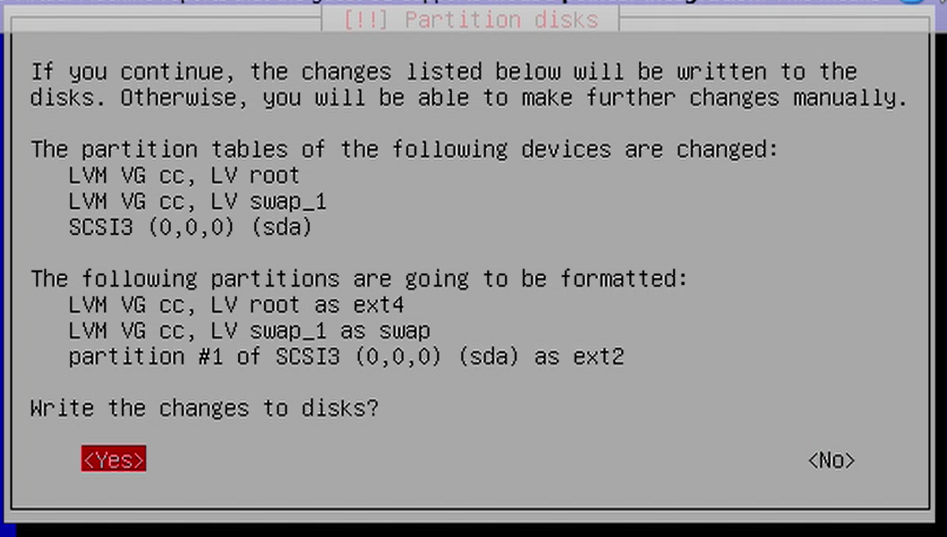

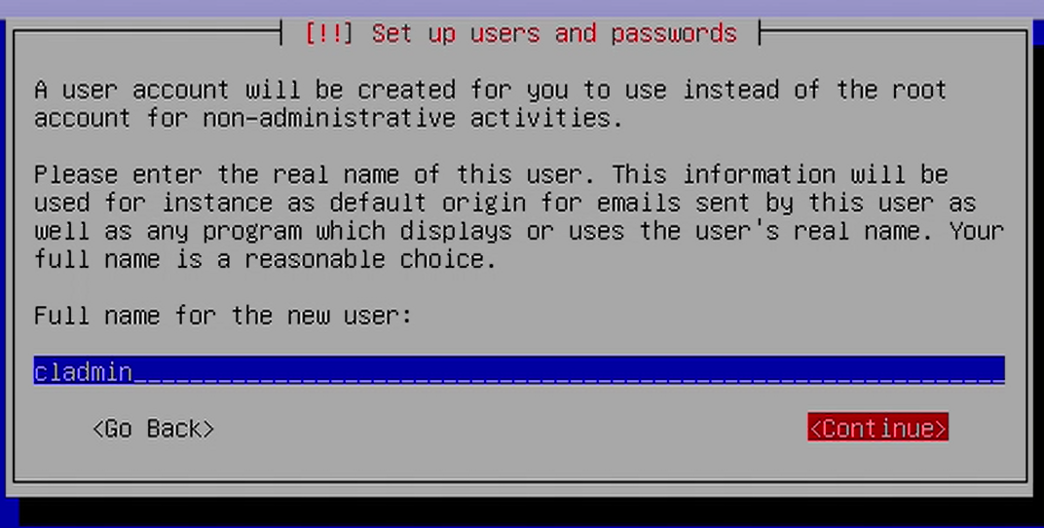

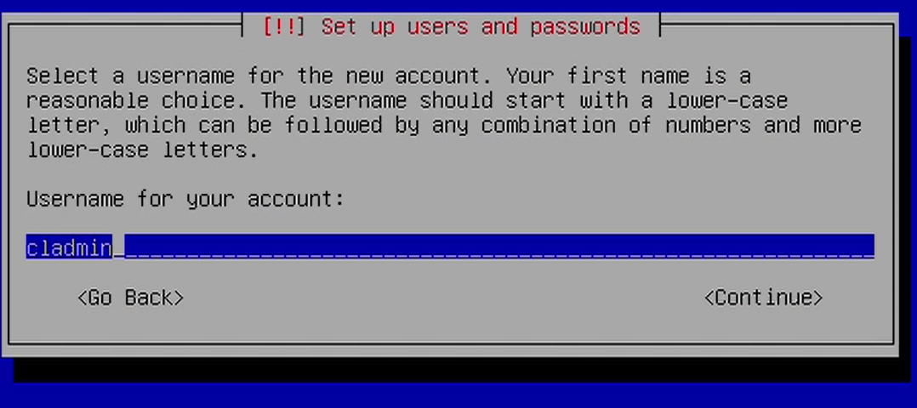

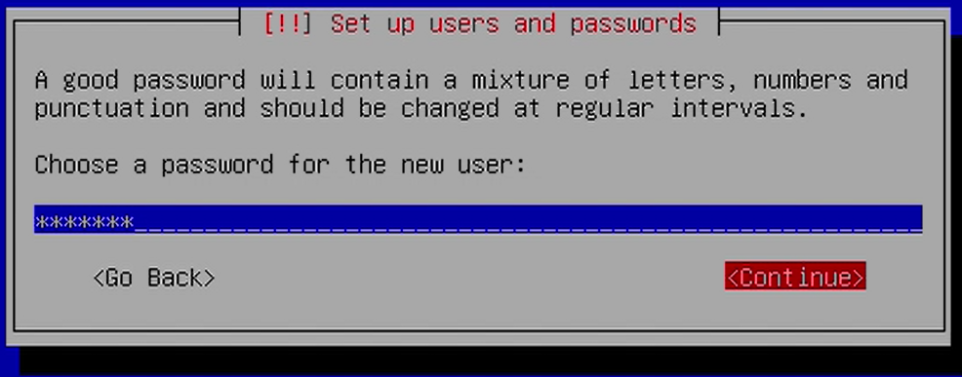

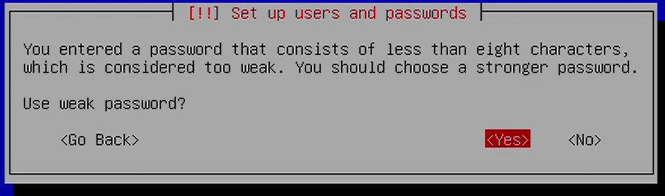

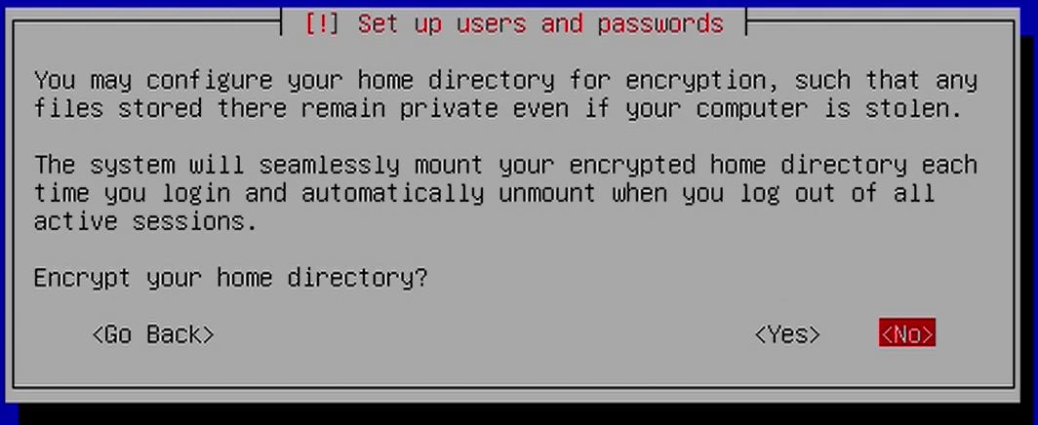

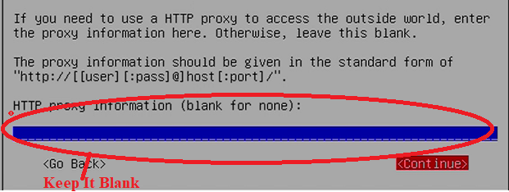

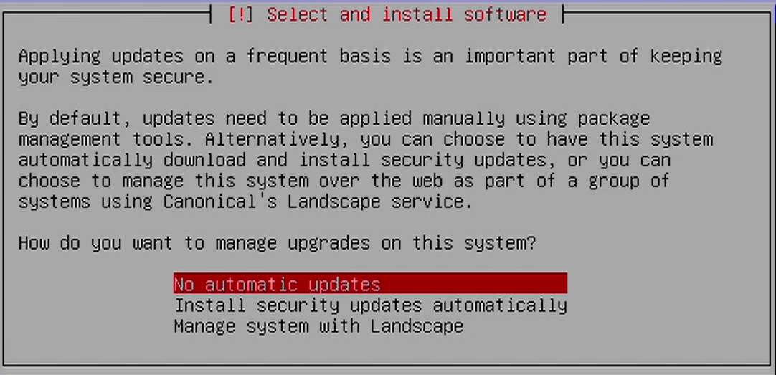

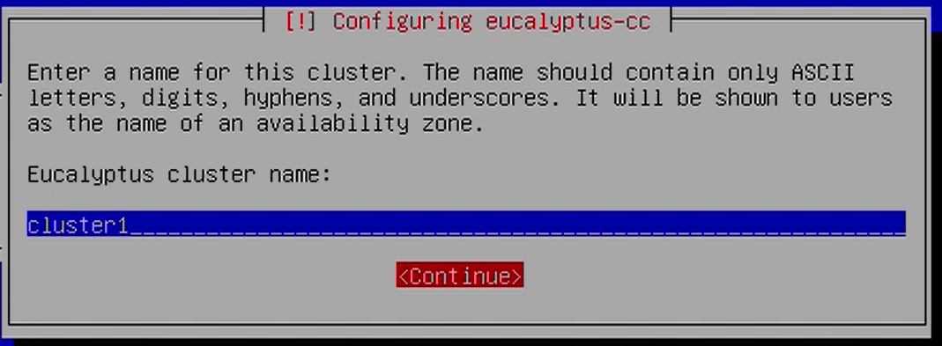

* **Public IPs**
* We provide a pool of addresses that will be automatically assigned to VMs when instances are created.
* These public addresses will be automatically assigned to VM instances to make them accessible from outside the cloud

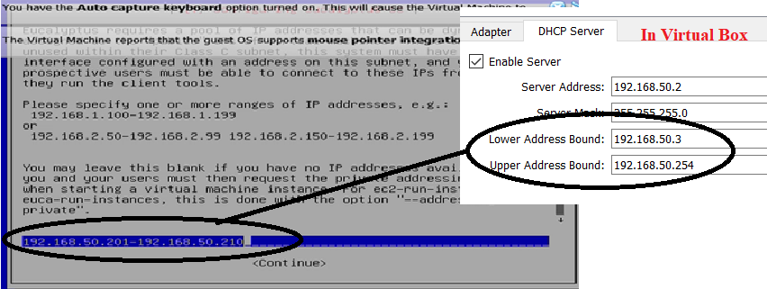

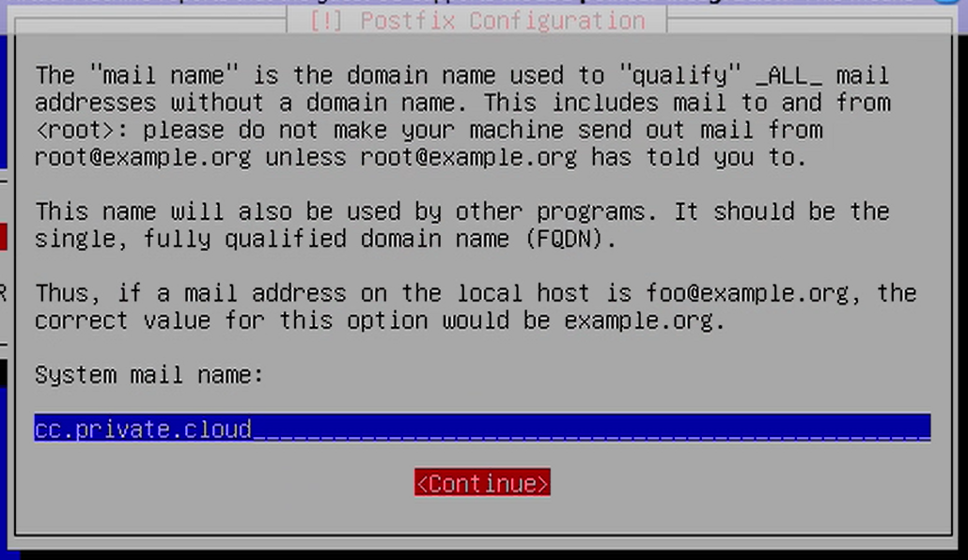

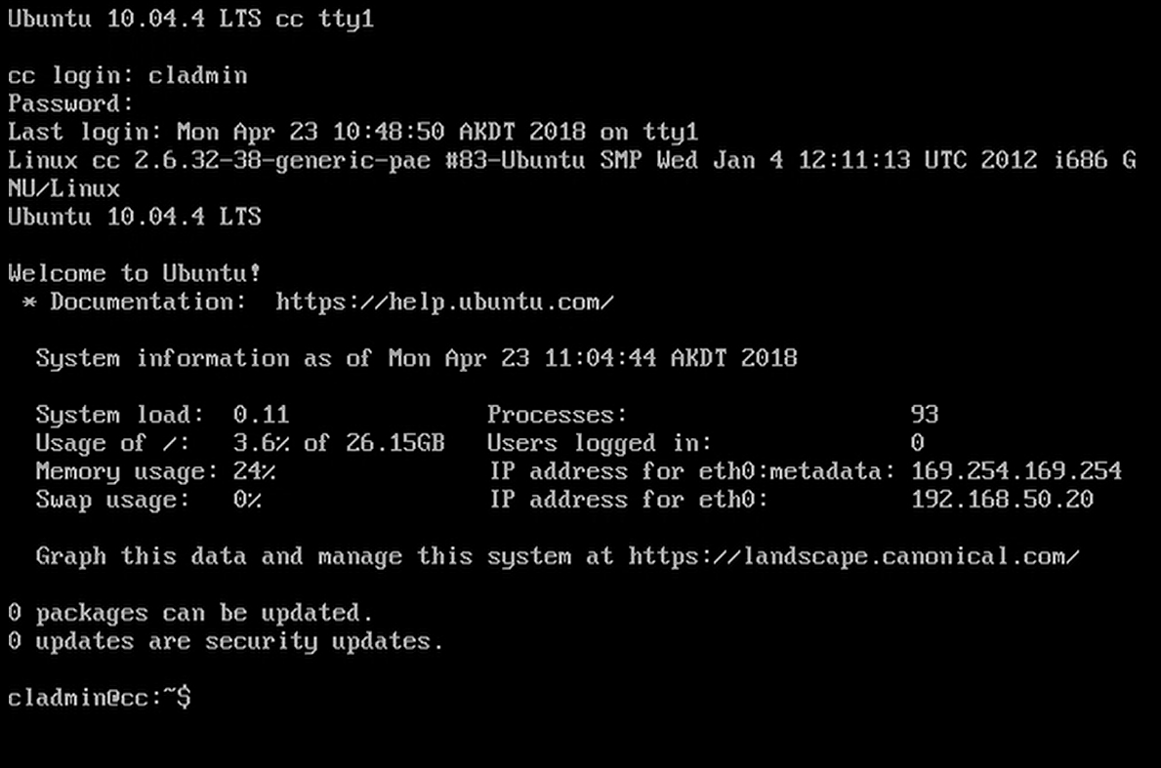

* **Setup Server-2 (Node Controller)**
  + Keep Server-1 running
  + For Server-2, we will do same it is as Server-1
  + But, We Select No of Processor =2

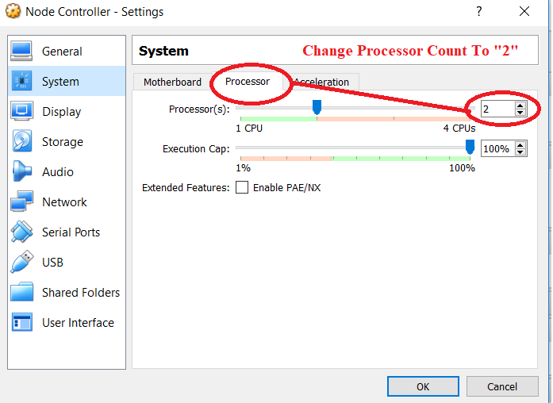

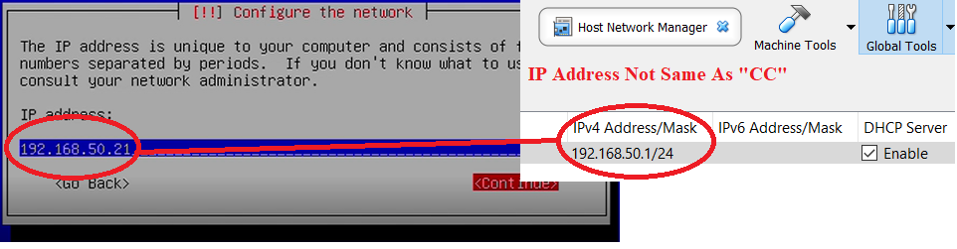

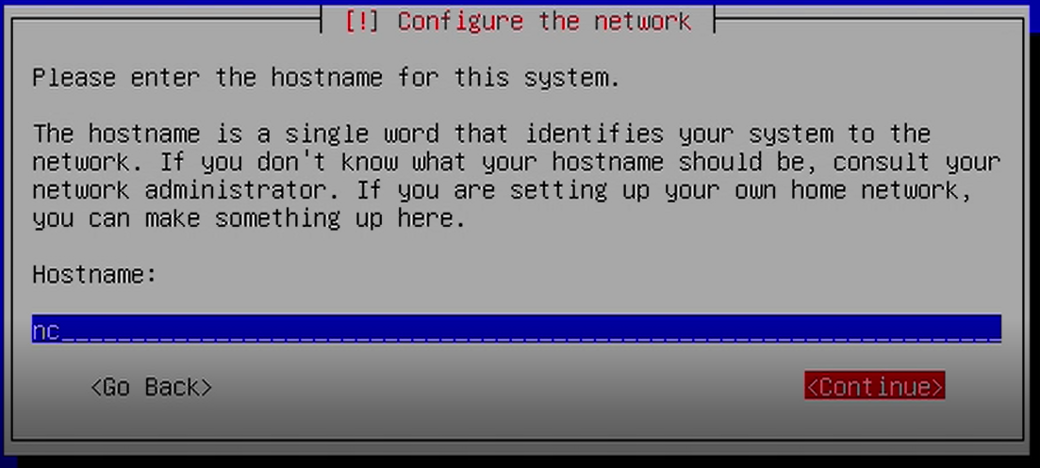

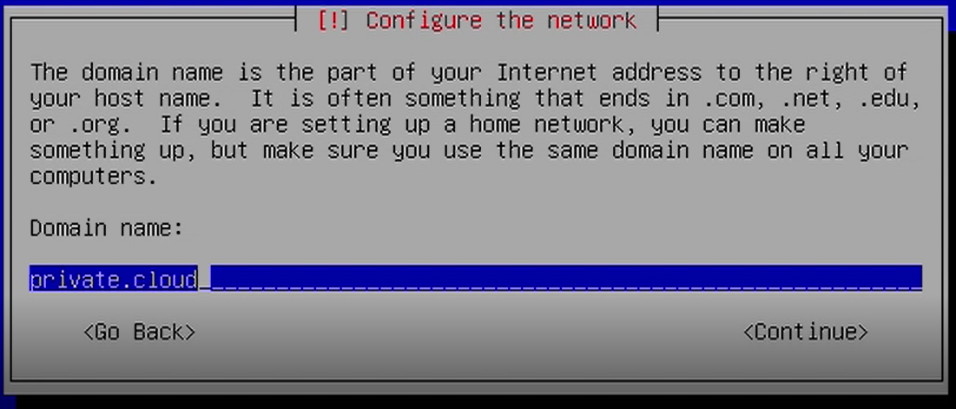

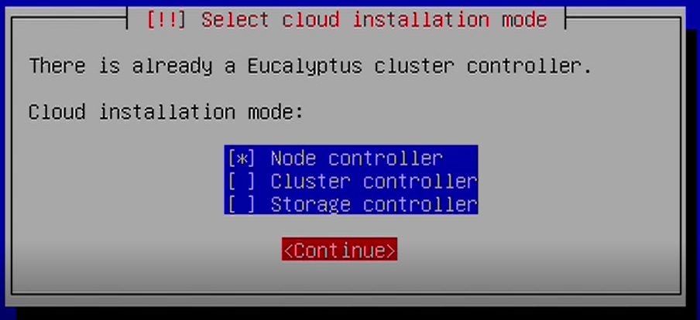

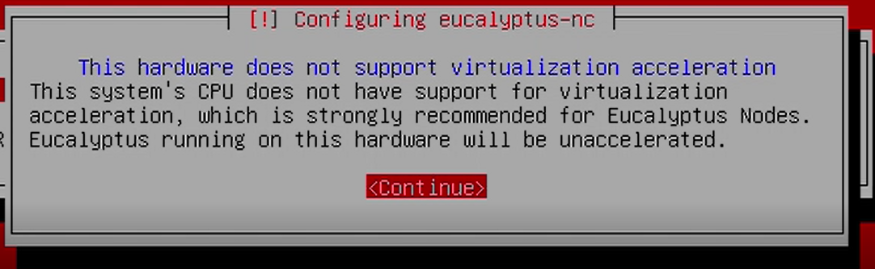

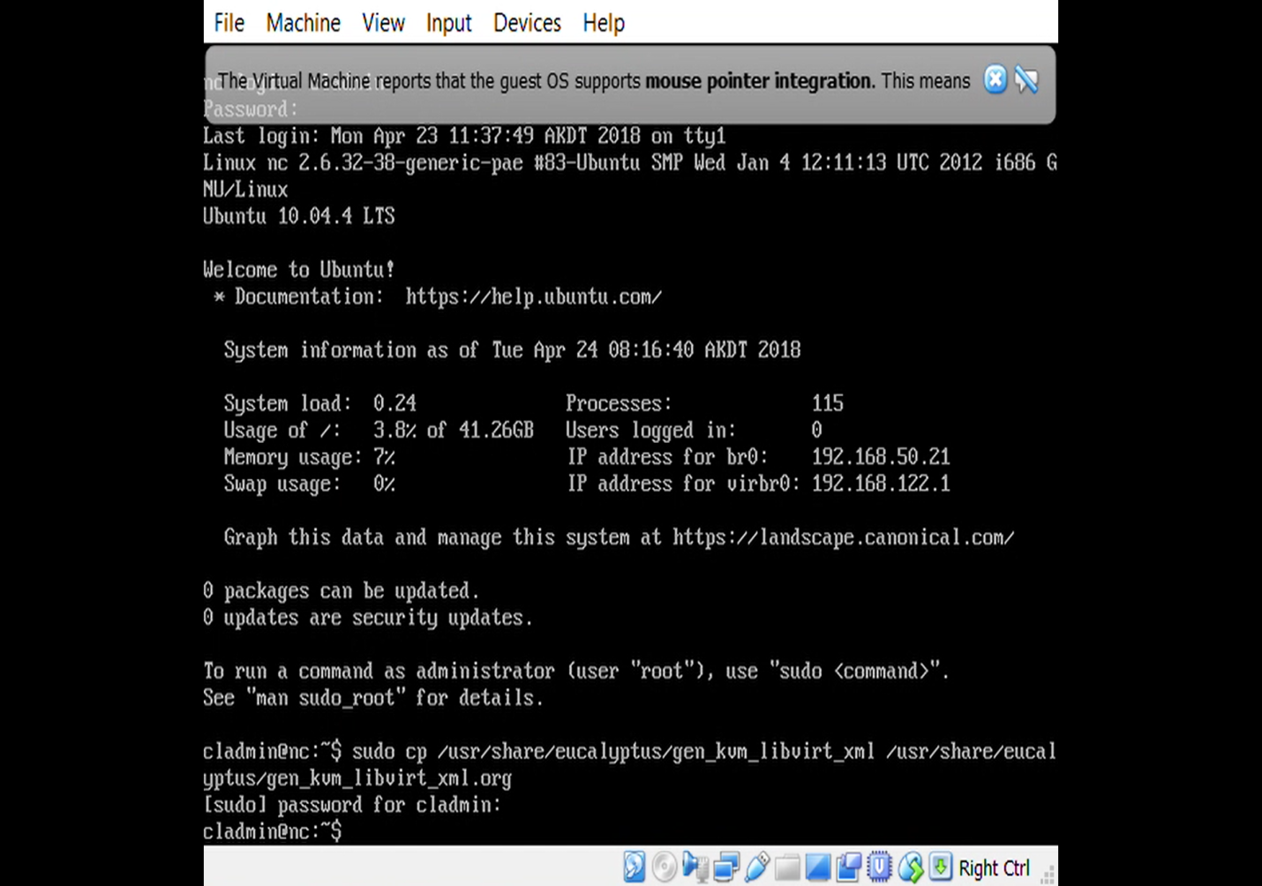

* **Installing Cloud Administrative Credentials through the Eucalyptus Web Interface**
* Step 1: Browse to web interface of eucalyptus (CC) from a networked machine on which internet browser is available. We used windows machine inside which cloud was setup.
* Login with default user name: admin and default password: admin
* USE URL=”Your CC IP Address”<192.168.50.20>

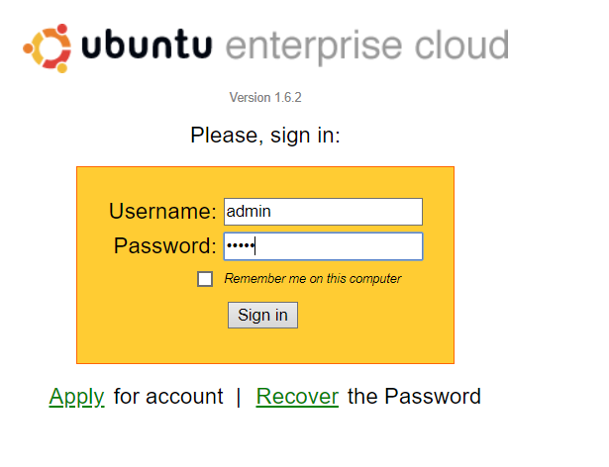

* **Step 1: Change password**

• Change password to adminadmin at first time configuration

• Specify email address of administrator as [cladmin@cc.cloud.private](mailto:cladmin@cc.cloud.private)

• Where cc is the host name of cloud controller and cloud.private is the domain that we assign (Domain name can be configured in /etc/hosts file)

* **Step 2: Download credentials**

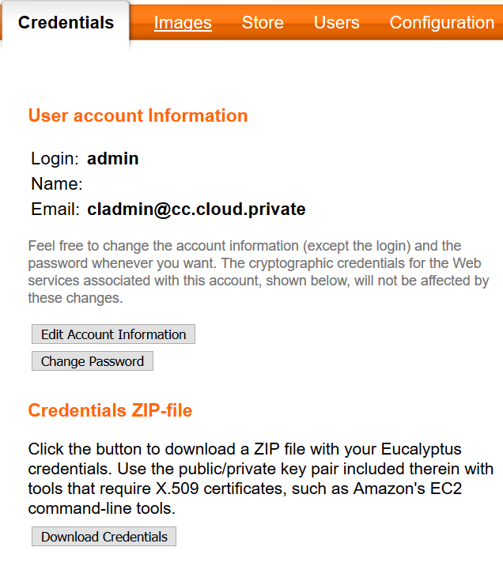

* **Step 3: Copy the downloaded file**

• Copy the downloaded file euca2-adminx509. zip to /home/cladmin folder on

The cloud controller (cc).

• You can use scp, ftp, sftp, or any other preferred method.

– scp euca2-admin-x509.zip cladmin@<cc-IP>:/home/cladmin

• If any of above is not available, we can copy using pendrive.

**Step 4: Save All Configuration**

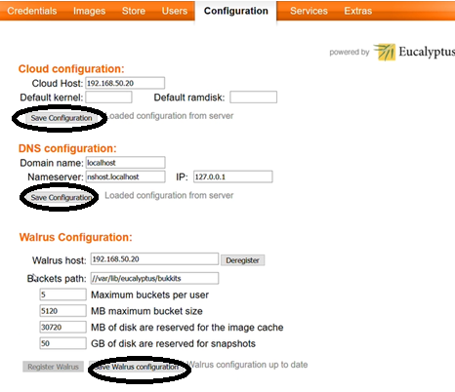

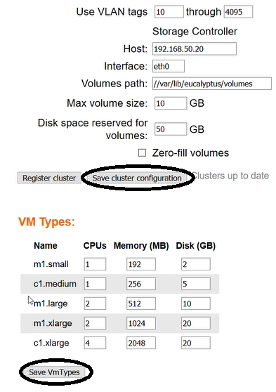

**Step 5: Extract file**

* Now we will create a .euca folder on the cloud controller (cc) and extract the zip file to this folder:

cladmin@cc:~$ mkdir ~/.euca

cladmin@cc:~$ cd ~/.euca

cladmin@cc:~/.euca$ unzip ../euca2-admin-x509.zip

**Step 6: Remove zip file and apply appropriate permissions**

* Because the credentials file contains information allowing administrative access to the cloud, it is recommended to remove the zip file and apply permissions to the .euca folder and its contents:

cladmin@cc:~/.euca$ rm ~/euca2-adminx509.zip

cladmin@cc:~/.euca$ chmod 0700 ~/.euca

cladmin@cc:~/.euca$ chmod 0600 ~/.euca/*

* **Without use of web interface how to set credential (OR Step 1,2,3,5,6)**

• Using command line on cc (cloud controller)

$ mkdir –p ~/.euca

$ chmod 0700 ~/.euca

$ cd ~/.euca

$ sudo euca_conf - -get-credentials mycreds.zip

$ unzip mycreds.zip

$ ln –s ~/.euca/eucarc ~/.eucarc

$ cd -

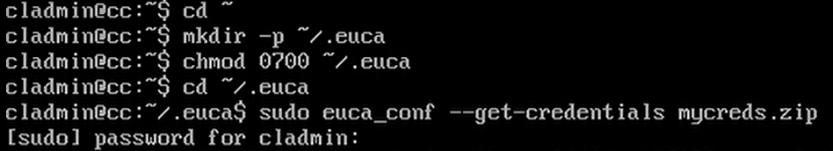

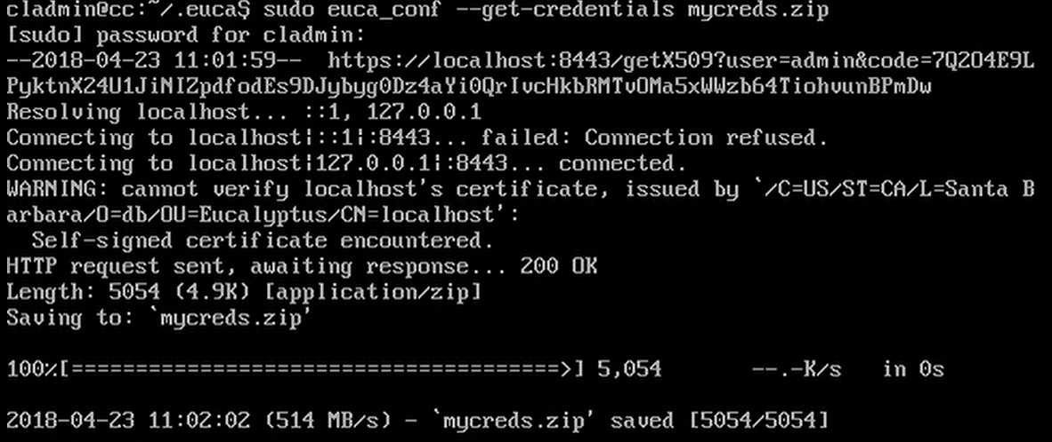

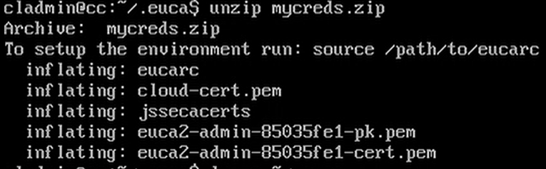

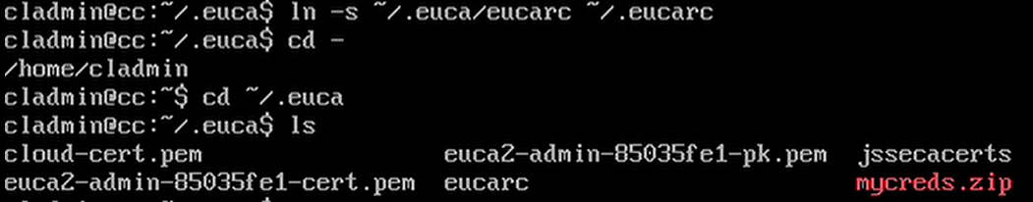

* **Configure login environment**

**Step 6**: Next we will add a line to the ~/.bashrc file on the cloud controller to

ensure the necessary environment variables are initialized upon login:

cladmin@cc:~/.euca$ echo “. ~/.euca/eucarc” >> ~/.bashrc

**Step 7**: Next we will source the .bashrc file to ensure our settings take effect:

cladmin@cc:~$ source ~/.bashrc

You can log off and back on in order to ensure these settings are active.

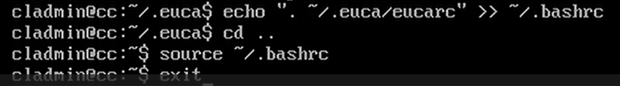

* **Accessing the Cloud**
* **checking resources available for hosting VM on cloud**

Step 1:

* Do not start any node controller and check resources using “euca-describe- availability-zones” command
* Our clc (cc) is running on 192.168.50.20

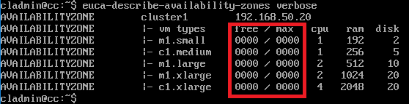

* We can see that we do not find any free resources for hosting new VM

checking resources available for hosting VM on cloud

Step 2:

* Start node controller and check resources using eucadescribe-availability-zones command

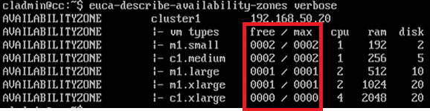

* We can see that now we find free resources for hosting new VM. We can start 2 instances of m1.small, 2 instance of c1.medium, 1 instance of m1.large
* **Image management**
* Eucalyptus Machine Image (EMI) is a bootable system
* EMI contains following
  + Kernel Image
  + Ramdisk image
  + Hard disk image
* We need to perform following for each image file
  + Bundle
  + Upload
  + Register
* **Get Eucalyptus Image file**
* It is preferable to directly download images on cc machine from emi repository
  + Internet access is required on cc
* We try to understand manual process
* We downloaded the following image for KVM hypervisor
  + **trusty-server-cloudimg-amd64.tar.gz**
  + **Also Available on “cloud-images.ubuntu.com”**
* **Transfer image file to cc**
  + We have image in our USB

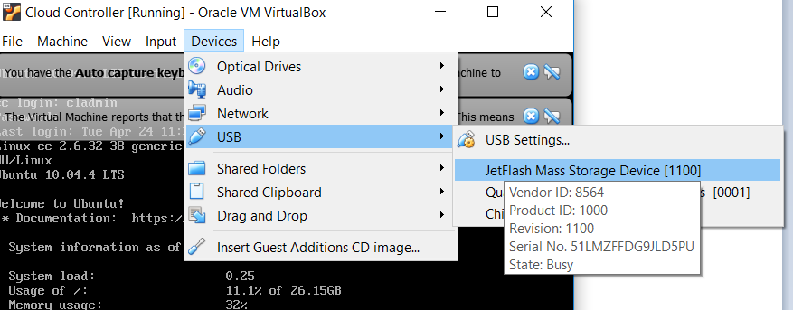

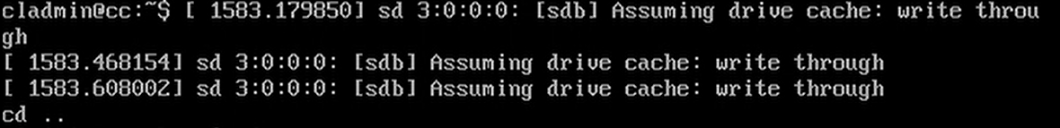

* + We transfer the image to cc

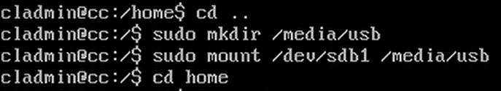

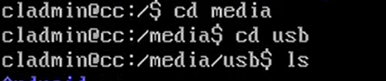



**Copy File to /home/cladmin**



* **Extract image file**
* Extract under home directory of cladmin on cc
* Command:🡺uce-publish-tarball trusty-server-cloudimg-amd64.tar.gz `x86_64`

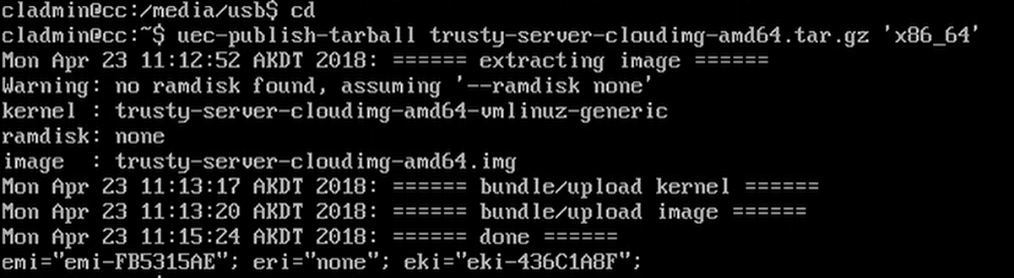

* **Image catalog in GUI**
* we can also browse using web interface on the
* following address

– <https://192.168.50.20:8443/#images>

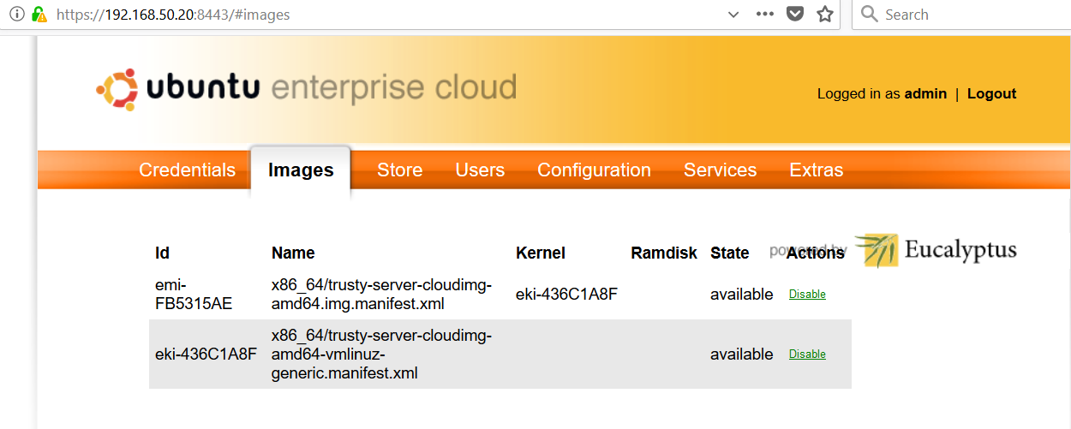

* **Browse Images**
* **Step 10**: Browse registered images

$euca-describe-images | grep emi



* **Key pairs for login to VM instances**
* **Step 11**: Add keypair

–Check key pairs using euca-describe-keypairs

* If key is not already added, add it using following

– $euca-add-keypair user-key01 > .euca/user-key01.pk

– $chmod 400 .euca/user-key01.pk

* **Security role (allow ssh login)**
* **Step 12**: Add security role

– Check security group using euca-describe-groups

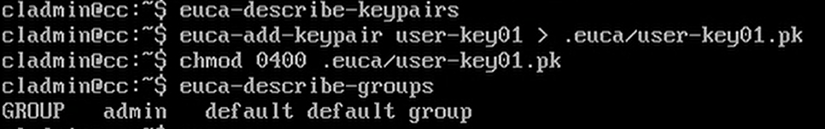

* **Security role (allow ssh login)**
* **Step 12**: Add security role

– If security group not already added, add it using following

$euca-authorize –P tcp –p 22 –s 192.168.0.0/16 default

$euca-authorize –P icmp –t -1:-1 –s 192.168.0.0/16 default

• -P 🡺protocol

• -p 🡺port no

• -s 🡺source network

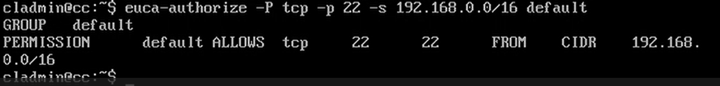

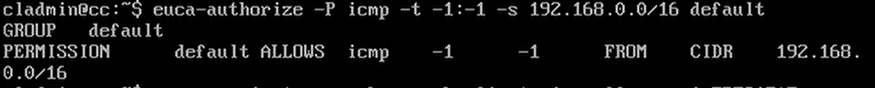

* **Launch Instance**
* **Step 13**: Launch an instance

– Find [emi id] using $euca-describe-images | grep emi

– Pass [emi id] to euca-run-instances command

$euca-run-instances –k user-key01 –t m1.small –n 1 <emi-XXXXXXXX>

Here

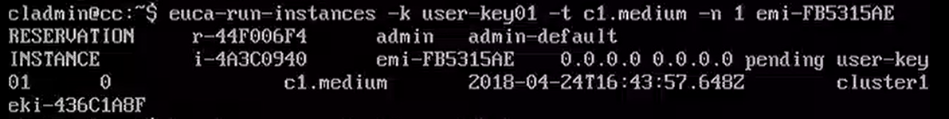

-k -> key

-t -> type (get it using euca-availability-zones verbose)

-n -> number of instances

Public key is injected in VM instance when it boots up. Therefore password less login is possible to VM

* **Check status of instance**

**Step 14:** Check status of instance

* + $watch euca-describe-instances

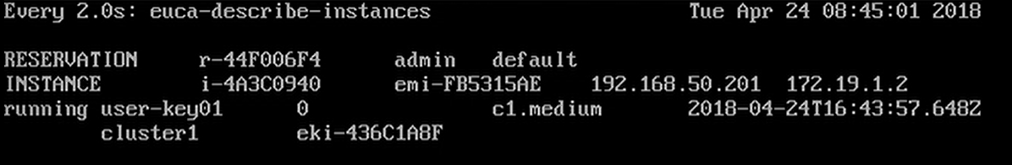

* **Modify kvm config file on nc**
  + Create a backup file:

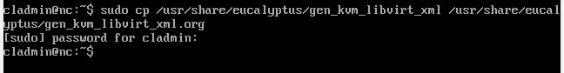

* + Modify domain information:



* **Modify kvm config file on nc**
  + Original

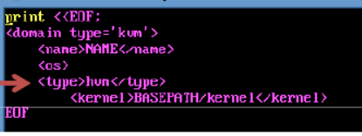

* + Modify to

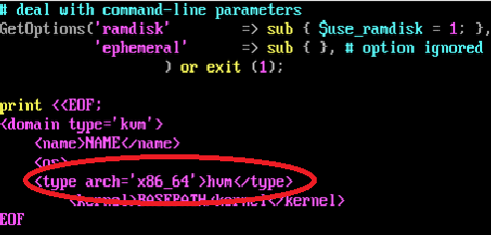

* **Run instance**
  + We selected c1.medium type due to insufficient space in t1.small



* **Check status of instance**
  + **Step 14**: Check status of instance

$watch euca-describe-instances

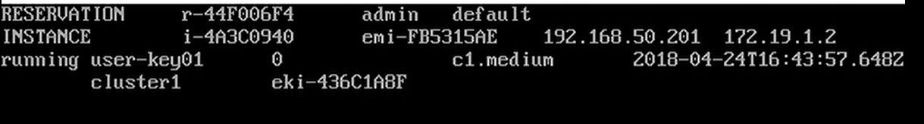

* **Login using ssh**
  + **Step 15**: Login to instance

$ssh –i .euca/keypairs/user-key01.pk [ec2user@192.168.50.20](mailto:ec2user@192.168.50.20)



OR

$cladmin@cc-64:~$ euca-get-console-output <i-xxxxxxx>

i-xxxxxxx is the instance ID.

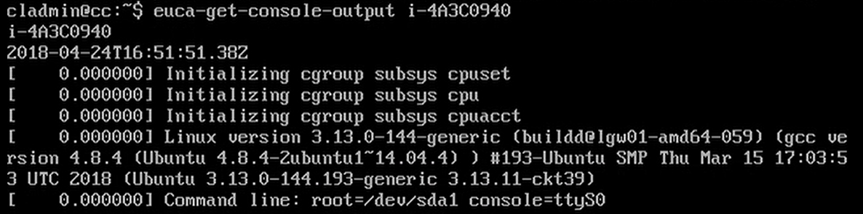

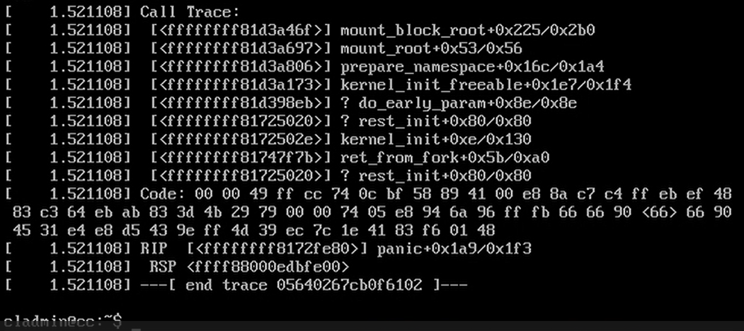

* **Clean up instance**
  + Terminate instance

$cladmin@cc-64:~$ euca-terminate-instances <i-xxxxxxx>

